Oliver McGowan - Expert by Experience (Learning Disability or Autistic) Trainer

Job Description

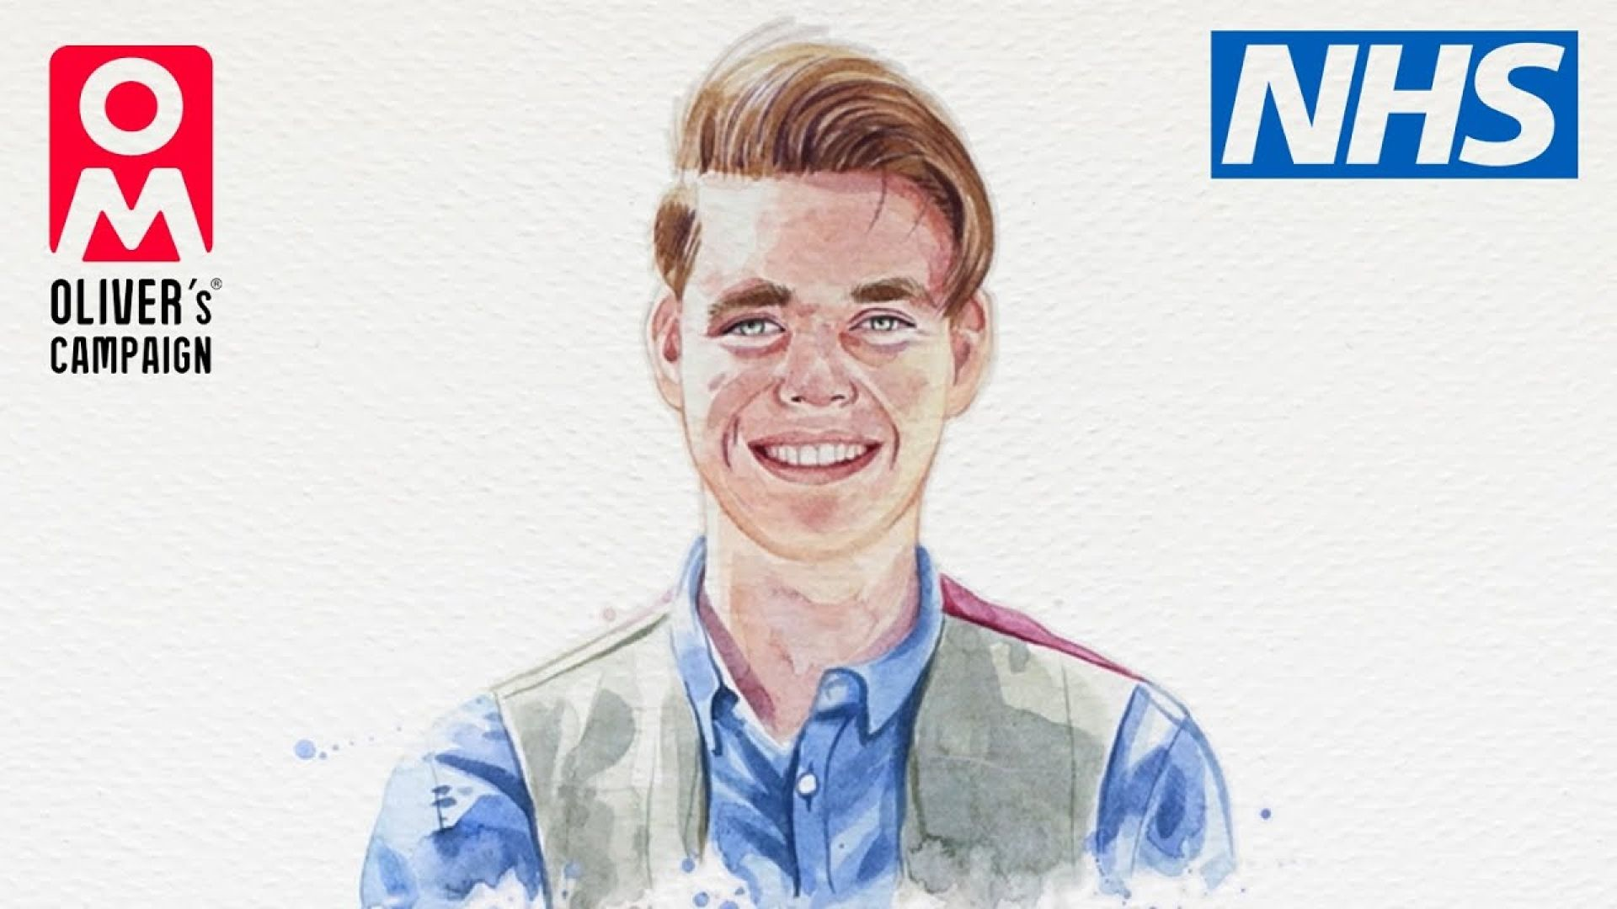 | Job title:  Oliver McGowan Trainer - Expert by Lived Experience
 | Department:  Learning & Community
 | Reporting to:  Training and Lived Experience Team Leader – Sam  You will have the opportunity for regular 1:1 support and development within the role.
 | Hours:  This is a casual contract.  This is because the training People First is asked to do each week can change. Training takes place between 9am-5pm.  Your days and hours you need to work are likely to be different each week. We will plan this with you giving as much notice as possible.  You will be paid for all hours that you work.
 | Contract:  This contract will last until October 2027.  We will review this regularly to make sure it is kept up to date. There may be an opportunity to extend.
 | Hourly rate of pay:  £16.41 per hour when delivering training  £14.24 per hour for admin, team meetings, learning and development etc.
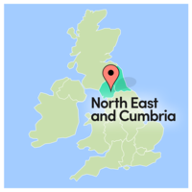 | Location:  Our Head Office is in Carlisle, Cumberland.  Oliver McGowan Training will mainly be delivered in Cumbria and Northumberland. You will be required to travel within these locations.  Sometimes our work can take us elsewhere for learning or new opportunities.  Your Team Leader will support you to make travel arrangements, and your travel will be paid.
 | Who we are:  People First is an independent, charitable organisation.  We have worked in the North of England for 35 years.  We believe that life is better for everyone when everyone is included.
 | Who we are:  People First works to ensure everyone has a voice. We are passionate about equality, respect, and inclusion.  All our support is aimed at helping people live informed, healthy, and fulfilled lives.
  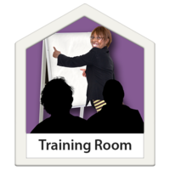 | The department delivers the following work:  - Oliver McGowan training  - Learning opportunities with the People First Academy  - Self-Advocacy and Youth projects in Cumbria  - Employment support with Creating Careers  - Projects focused on addressing health inequalities  - Care and Treatment Reviews  And much more...
 | Who are we looking for:  People with lived experience of a learning disability or who are autistic, to join the Oliver McGowan Training Team.
 | Who are we looking for:  Someone who:  - Is passionate about improving the lives of autistic people and people with learning disabilities.  - Enjoys being part of a team and might have experience of this.
 | Who are we looking for:  - Has a range of experience using health and social care services.  - Is willing to share their knowledge and experience to help inform others.
 | What will you be doing?  Your job will be to work alongside a facilitator and another expert to deliver the Oliver McGowan training on learning disabilities and autism.  You will be training professionals who work in Health and Social Care.  This will be done online and in person, face to face.
 | What will you be doing?  You will be asked to talk about some of your experiences of the health and social care system with professionals attending the training.
 | What will you be doing?  You will share National and Regional information to help people’s learning.
   | What will you be doing?  You will also help develop the delivery of the Oliver McGowan training.  Share ideas, look at feedback, thinking about what works well and where improvements in the delivery, resources etc. can be made.
 | Essential skills, knowledge, and experience:  Good communication skills – written, verbal, listening and understanding.
 | Essential skills, knowledge, and experience:  Delivered training or experience of speaking up in group or public situations.
 | Essential skills, knowledge, and experience:  Reliable, good time keeping.
 | Essential skills, knowledge, and experience:  Organised, able to meet deadlines.
 | Essential skills, knowledge, and experience:  IT skills or willingness to learn use of Microsoft Teams.
 | Essential skills, knowledge, and experience:  Supportive and encouraging towards team and people attending the training.
 | Essential skills, knowledge, and experience:  Knowledge of Oliver McGowan’s story and why the training was created.
 | Essential skills, knowledge, and experience:  Understand the importance of people’s rights.
 | How do I know if my application was successful?  If your application is successful a member of our team will be in touch to arrange an interview.
 | Interviews:  If invited to interview there will be an opportunity for you to tell us if you need any support or reasonable adjustments with this part of the recruitment process.
 | How to apply:  Please complete the Expert by Experience application form and return by email to recruitment@wearepeoplefirst.co.uk  Or send us a video answering the questions to – recruitment@wearepeoplefirst.co.uk
 | How to apply:  Or you can return it in person or by post to:  FAO: Sam Drude (Confidential)  Learning & Community Department  People First Conference Centre  Milbourne Street  Carlisle  CA2 5XB
Do you have any questions?

If you would like any more information or an informal chat about this role, please contact Sam on 01228 474808 or via email samantha@wearepeoplefirst.co.uk

