Name:

Phone number:

Email address:

Address:
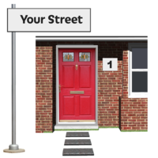
Please tell us about your disability.  For this role you need to have a diagnosis of either... | Learning disability | Autism | Both
How do you want us to contact you?   | Phone | Email | Post

Tell us about any experience you have that will benefit you in this role?


Tell us about what knowledge and skills you will use in this role?



What experience do you have of delivering training or speaking up in public?


What do you know about the importance of people’s rights?
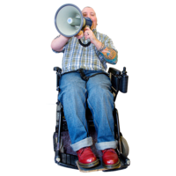

What experience do you have of using Microsoft Teams?
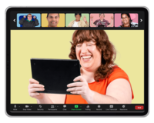
What do you know about Oliver McGowan’s story?
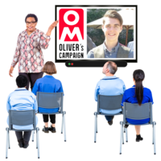

Why do you think this training is important?

Why do you want this job?

Is there anything else you would like to tell us?



Thank you!

