

People First Creating Careers Application
Full Name

Date of Application
Preferred Name
This is what you like people to call you

Gender

Date Of Birth and Age
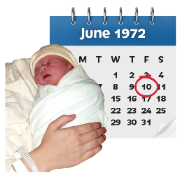

Your Email

Address & Postcode
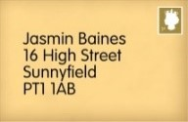

Your Telephone Number

Next of Kin details, who do you want us to contact in case of an emergency or about your course?

Name |  |  | Address/Telephone/Email | Relationship
Designated Contact from above, if applicable:
Are you an Autistic person, have a learning disability or identify as a Neuro-diverse person?
Do you know what kind of work you would like to do?
Have you had experience of working before? If so, please tell us about your experience?
Tell us about your interests and why you are interested in the course?
Please return to; Admissions at admissions@wearepeoplefirst.co.uk or alternatively return to Emma Lyons (Employability Team Leader), People First Conference Centre, Milbourne Street, Carlisle, CA2 5XB or emma.lyons@wearepeoplefirst.co.uk
The information collected on this form will be used to help us form an assessment of your needs for the course. We will only keep it for the time you are with us, and we will not share it with anyone outside People First.

