


Friends and Relationships
Subgroup

Meeting Minutes – what was said at the meeting.







Item | Subject
  1. | People who were at the meeting:    Sarah McDermott – Co-Chair, People First  Sue Sharples – Co-Chair, U-Night group  Linda Stewart-Co-Chair, People First  Joanne Kennedy- SeeAbility, Pathways  Andy Billington-Shared Approach  Martin Faulkner-Shared Approach  Lucy Hamlin-Spring into Action  Caroline Moon-Adult Social Care  Georgina Pinder-Adult Social Care  Tania Cockcroft- Sexual Health Services  Julie Madden- Integrate  Emmy Walmsley- People First  James Hughes- People First  David Sellers, LSCFT  Mark Hampson - People First    Apologies:  Jeannette Doherty  Natalie Vranjes  Bradley Wilson  Rebecca Gammon
  2.  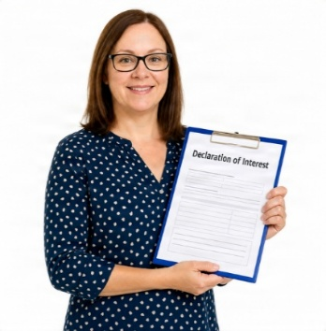 | Minutes from the last meeting  - We did not agree the minutes. There had been a problem with recording them.  Declarations of interest  - People must say if they do other work that might effect decisions they make here.  - No one had any issues
  3.       | Matters Arising / Actions Review  - Culturally sensitive sex education  There will be another meeting about culturally sensitive sex education.  The views of family members are being collected by a Social Worker.  - Intimate Lives Matter project  Some Lancashire Social Workers have done the online course.  Georgina said she is using the forms already.  Sue will talk to Neil Willcocks about wider use.  Face to Face training for Lancashire’s Social Workers about Care Act assessments is on Friday 25th September.  - Responsibility for doing capacity assessment  Sue has spoken to Neil Willcocks about this.  It was agreed that more discussion is needed between LSCFT and Adult Social Care.  Senior managers need to be involved.  We said that the assessment should be undertaken by the professional who knows the individual best.  The assessor should have training and resources to do a good job.
  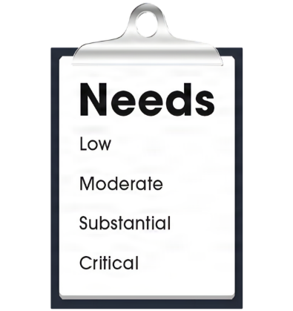   | - Easy read information.  The Partnership Board has agreed to have a group about easy read.  They will develop a plan so that everyone knows the standard expected.  It will also look at who can provide support and training in Lancashire.  Action: Sarah will write to Adult Social Care to ask  about easy read assessment information.  James to chase the easy read financial assessment document  Georgina/Caroline to find out who has access to Photo symbols in LCC.  Sexual Health Service Leaflet  Tania has written to the Managers who gave feedback. She has not had a response.  Tania asked if black and white print was as accessible as coloured print.  The self-advocates said easy read in colour is much better to understand.  Action: Tania will remind the Managers, so that the new edition can be published.  Tania to look into accessible information for the home testing kits.
     | - Sex and relationships policy framework  This is ready to be sent to all organisations.  It will help them to develop and review their policies.  We talked about how we can promote it widely.  Action: Sue to ask Tara if she is still managing the Provider Forum. If so can she attend to share the information.  - Talking to people in Parliament  Sue struggled to contact Andy Burnham and 10 Downing St.  She did get in touch with Samantha Niblett, M.P.  She is raising awareness of sex education for adults.  It was called the Summer of Sex.  Sue has given her questions about inclusion to raise in Parliament.
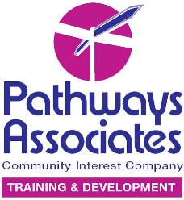    4. | Feedback from the Partnership Board  Pathways Conference  The report is now available.  We need to think about what this means for Lancashire.  Action: Someone from Pathways is being invited to the Partnership Board
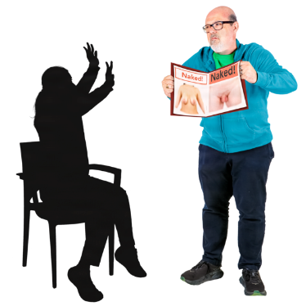  5.   | Sexual safety information  The group think it will be helpful to understand about the figures for sexual abuse in Lancashire.  We also want to know what support people get after they have been involved with safeguarding.  Action: Holly Holt from the safeguarding team, has been invited to the next meeting
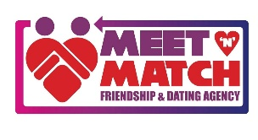    6.     | Meet ‘n’ Match / Spring into Action Updates  Lucy told us about the successful 10 year anniversary Ball and the Stephen Haywood Award.  Sarah received a highly commended award.  A toolkit/framework is being developed. This will help other organisation, across the country to run events and dating/friendship support.  A new eight-week Train the Trainer course is starting soon.  It will also be run in Blackpool and Greater Manchester.
  7.   | Review of our action plan  Under the heading of Education we discussed what we have achieved and what still needs to be done.  It was agreed that there are still barriers to people with a learning disability and staff getting training.  We did an exercise to help us understand about our own learning and what would help.  Action: This information will be part of our plan.
  8.       | Feedback from London Conference  Sarah and Sue spoke about the Shout about Sex conference in London.  They mentioned:  - Their visit to the Vagina Museum  - Attending workshops  - A talk from CQC  - Doing their own games workshop  - Networking  - Learning new teaching techniques  - Being proud to tell people about the good work  in Lancashire  Action: Tania told us that the British Association of Sexual Health is having their Conference in Blackpool next year.  She is going to see if the FAR Group could be involved.  Sarah will find out the name of the Drama Group that presented at the Shout Out conference.  https://accessallareasproductions.org/production/not-fkin-sorry/
      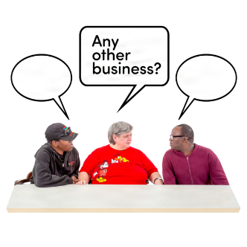  9. | Any other business  Sue gave an update on the U-Night groups Loss and Bereavement project  She thanked everyone who has made suggestions about what should be in the pack.  2 sets of cards and other activities have been made already.  They will be trialled with Shared Approach in a few weeks.  Joanne and Linda told us about next year’s Pathway’s Conference.  They are going to ask if the FAR group can do a workshop  Choice Support manages the CQC experts by experience scheme. The are looking for people to help with inspections. You would get paid for doing this job.

