



Meeting Minutes







Ribble Suite, County Hall, Preston

  Item |  | Subject
1. |  | Welcome and introductions.  - Esther Smith (Advanced Clinical Practitioner, Lancashire & South Cumbria Foundation Trust)  - Imogen (Peer Support Worker LSCFT)  - Linda (Co-chair, Learning Disability Board)  - Joanne Kennedy (Seeability)  - Julie Madden (Integrate)  - David Lowry (Learning Disability Nurse)  - Louise Calvert (People First volunteer)  - Emmy (new Peer Advocacy Network Facilitator)  - James Hughes (Team Leader, Peer Advocacy Network  - Steve Kill (Seeability – eye care access for people with learning disabilities)  - Justine Eaton (LSCFT)  - Tracey Hartley Smith (independent Clinical Nurse Consultant volunteer, based in Gold Coast, Australia)  - Crystal Small (Health Facilitation Nurse, LSCFT  - Sahid Mohamed PSW (LSCFT)  Apologies  - Debbie Leigh- Parent and Activist  - Alistair Aspinall- Learning disability Nurse for LSCF
2. |  | Update of Minutes / Matters Arising  - ICB representation:  The group has no ICB representative attending (previously Lisa Denicola). This has been raised at the Lancashire Partnership Board and staff feedback without resolution. Lindsay Graham was tasked with escalating the issue to a named contact (later confirmed as Neil Greaves) via the Health and Wellbeing Board. Crystal noted the ICB is undergoing significant restructuring, which may explain the lack of response, though the group felt a simple acknowledgement email would help.  - Tracey suggested contacting the Blackburn with Darwen Learning Disability Partnership Board, which also lost its ICB rep (via Lisa), to compare experiences.  - Previous actions reviewed: request for 2023 local LeDeR report (update given later in meeting); GP Health Action Plan feedback (update given later); A&E top tips leaflet (updated later); NHS app availability for health action plans (Crystal to check).
3. |  | Declarations of interest.  None declared
4. |  | Tracey Smith Presentation – Future of Learning Disability Nursing  Tracey presented on a new RCN document, "How We Want to Make Learning Disability Nursing Better," highlighting:  - Learning disability nurse numbers in the NHS have fallen by a third since 2009.  - In 2025 only around five hundred people across the UK enrolled on learning disability nursing courses – a 40% drop in accepted students over 10 years.  - Consequences: poorer health outcomes, reduced reasonable adjustments, and patient safety/human rights concerns for people with learning disabilities.  - Regional disparity: more course availability in the Northwest than southern England; bursaries support students in Scotland, Wales, and Northern Ireland.  - National plan: double training places by 2031/32, with an expert group reviewing recruitment and workforce; RCN review made ten recommendations.  Tracey's proposal: form a 6-month local task and finish group to:  - Map how many learning disability nurses/students are in Lancashire (NHS and wider), including course completion rates and upcoming retirements.  - Gather family/service-user stories showing the impact of learning disability nurses.  - Develop a local education and employment plan, involving people with learning disabilities and families centrally.  - Report progress to the partnership board.  Discussion: Group agreed this should go beyond the partnership board to the Health and Wellbeing Board (which Jackie Shenton attends) and potentially the Best Practice Group (BPG) for LD, to reach frontline nurses and their service users. Universities to approach: Edge Hill and UCLan (focus on Lancashire-based institutions to avoid scope creep). James suggested collecting case studies of poor outcomes linked to nurse shortages to strengthen the case, supported by LeDeR report statistics. Esther to convene a follow-up meeting to plan membership and next steps (including university reps, family carers, and people with lived experience).
5. |  | Down Syndrome Act 2022  No update yet on whether statutory guidance has been published following the Down Syndrome Act (2022) and following the consultation. Item to remain on the agenda until confirmed.  LeDeR Report (Local)  - The group has struggled to obtain the 2023 local Lancashire LeDeR report from the ICB despite repeated requests to the ICB; Esther eventually obtained it via the LSCFT's Mortality Lead rather than the ICB.  Esther shared copies within the meeting but these were not easy read.  - The Down syndrome and death certificates issue was discussed at length: Down syndrome (and learning disability) continues to be recorded as the primary cause of death rather than the secondary cause and/or a contributing factor. This was raised at the partnership board and the Northwest "Good Health" meeting. The Down Syndrome Association confirmed they are raising this nationally with the Department of Health and Social Care, supporting individual family complaints, and working with ICBs including delivering training.  - Joanne reported that funding for the Easy Read LeDeR annual reports (produced with Kingston University) has been stopped; the university-led project is ending. The group had not been informed of this decision and expressed frustration.  Action: send out Easy Read Local LeDeR report to group members
6. |  | A&E – Top Tips  Crystal presented a draft "top tips" leaflet for attending A&E, incorporating feedback from a previous meeting. Agreed changes:  - Add a mental health crisis line (Lancashire's IRS number) as an alternative to attending A&E, since a crisis line offers a faster response than long A&E waits.  - Reword the section about seeing a doctor after triage for clarity (Crystal to redraft).  - Keep the leaflet concise, avoiding a full list of alternative services (e.g., walk-in centres) since provision varies by area — instead, point people to "speak to your GP" for local options.  - Add a reminder to bring hospital passport, slings (if personally required, not the hoist itself), medication, and pads/continence items.  - Reinstate a simple, brief reminder to bring money (for taxis, drinks, vending machines), worded plainly to avoid taking up extra space.  - Reinforce the value of bringing someone familiar for support, given memory/communication needs.  The leaflet is to go to the partnership board next for further distribution guidance, with an agreement to stop seeking further feedback rounds ("we could go on and on") and finalise it.  Action: Once completed take this to the Partnership board for feedback and distribution
7. |  | Feedback from See Ability  - This week is International Eye Care Week; Seeability is releasing daily short videos on social media, and Steve offered to share these with LSCFT staff more widely, including peer support teams outside Preston.  - Joanne took part in a national BILD (British Institute of Learning Disabilities) / GOLD online seminar on eye care with two hundred attendees.  - Joanne is doing training work with Specsavers in Preston, who are introducing quieter evening appointment slots (from 5pm) for easy eye care, following CPD/PGD training from Seeability, planned for October.  - Joanne to remain involved in upcoming diabetes-related filming work when scheduled (Crystal to confirm timing).  - Joanne also attended a Mencap conference in Liverpool on getting people with learning disabilities registered for annual health checks.
8. |  | Break
9. |  | Crystal Small from LSCFT Health Facilitation Team  - Prostrate Cancer  Members from the group were absent so we requested this item but is not present, so the full presentation was rolled over to the next meeting. Brief discussion noted general low awareness among group members about prostate cancer, PSA blood test levels, and the importance of raising awareness given increased national attention on the topic.
10. |  | Feedback/Update from Crystal Small  - GP Actions Plans  Crystal explained that GP-generated Health Action Plans (distinct from broader holistic Health Action Plans used by carers) are automatically produced in Easy Read format following annual health checks, covering follow-up appointments and who is responsible for them. Feedback from focus groups/workshops was positive and has already been implemented into GP systems.  - Discussion on whether these could be stored on the NHS App: Crystal explained this varies by GP surgery and is outside the group's control, though currently a paper copy is given to the patient.  - Concern raised about paperwork getting lost in supported living settings, risking missed appointments; suggested exploring digital storage options, though ownership of this issue is unclear.  - Crystal confirmed helpful feedback led directly to the plan's adoption on GP systems.
12. | 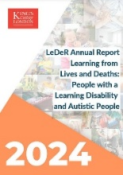 | LeDeR National Report 2024 what does the report tell us?  The 2024 national LeDeR report has been published; the local Lancashire report is still outstanding. Key themes highlighted from the report:  - Respiratory illness remains a leading cause of death.  - Preventable causes (e.g., cancers) were discussed, along with progress in bowel cancer screening uptake within the community — attributed partly to peer-led encouragement.  - Continued education efforts include GP trainee sessions delivered by self-advocates (Louise and others) at Lancaster University to medical students.
13. |  | Partnership Board Feedback- what do we want to feedback to the board from the health group?  Items to report to the partnership board (next meeting 14 October):  - Learning disability nursing workforce concerns (from Tracey's presentation).  - Down syndrome and death certificate recording issue, including correspondence with Neil Greaves and the Down Syndrome Association.  - LeDeR local report delays and missing Easy Read reporting.  - A&E top tips leaflet, once finalised, for wider distribution guidance.
14. | 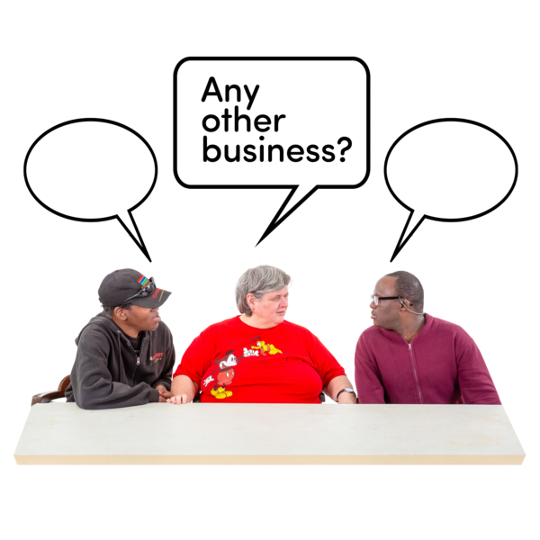 | Any other Business  - A group member (Louise, supported by James/Mark) delivers annual communication-awareness training to University of Lancashire students (social work, nursing, pharmacy, medical, and paramedic science), highlighting real cases where poor communication contributed to harm or death, including a case involving a man with Down syndrome who died of severe constipation/impaction due to a change in diet at a care home.  - Tracey highlighted the value of lived-experience-led training, noting this approach isn't yet common in Australia, and mentioned the Winston Churchill Memorial Trust Fellowship (closing soon to applications) as a possible funding route for international learning exchange, referencing a previous fellowship held by Sue Sharples.
15. |  | Next meeting?  - 11th November 2026  - 10.30 – 12.30pm
16. |  | End of meeting.

