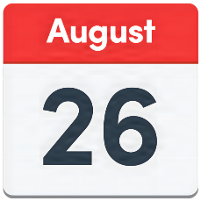

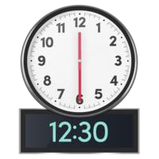
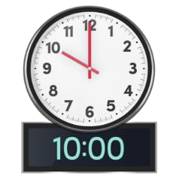
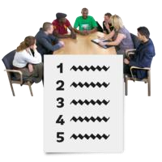
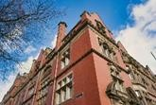

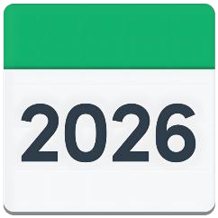

Meeting
Minutes

Jordan Suite,
County

Hall, Preston
.

Item |  | Subject
1. |  | Linda and Lindsay welcomed the group.  Everyone introduced themselves.  People who attended the meeting were:  - Linda Steward- Co-chair to board  - Lindsay Graham- Co-chair board  - James Hughes- People First  - Mark O’Farrell- Co chair Health task group  - Sue Sharples- U-night Group  - Gaynor Hargreaves- Lancashire County Councillor (Disability champion)  - Stephen Smith- People First- project worker  - Sarah McDermot Co-chair of Friends and Relationships subgroup  - Jean Grey- Co-chair of Friends and Relationships subgroup  - Emmy Walmsley- People First  - Jon Soros- Principle Social worker adults, health and wellbeing.  We had apologies from  - Esther Smith- LSCFT LD services  - Dave Spencer- People First  - Richard Woods- People First project worker  - Mark Howard- Peer Advocate for North  There were no declarations of interest shared.
2. |  | The minutes were agreed from the last meeting.  We talked about how Lindsay would contact Mark Warren to ask about the strategy.  Sue mentioned how it would be good to have a carer representation on the board.  - Actioned: Lindsay to contact Mark Warren  - Action: James to check where the financial  - assessment easy read version is.  - Action: Add sex and relationships document to Board Facebook page.

3. | 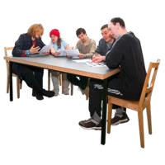 | The actions from the previous meeting were reviewed. Please see the Action Log for updates.  - Action log no.100- Nick C has now left and Gareth Flemming is now taking over.  - No.101- LeDer report needs chasing, lindsay to do that by contacting Neil Greaves.
4. | 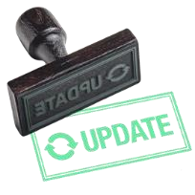 | Linda and Lindsay gave an update from the Chairs.  Told the board about the new structure in place for Peer Advocacy Network.  There have been many changes, and we have welcomed two new project workers and a facilitator to the team.  The Partnership board all thanked the previous team members for all their hard work and support in their time at people first.
5. |  | Introduction to Jon Soros  Jon Soros who is the Principle Social worker for adults, health and wellbeing did a talk about his role and how he can work with the partnership board moving forward.  He explained his role in detail and how he supports staff and members of the public to ensure they are heard and they gain the support they need.  Please see Jon’s presentation for more information.  
6. |   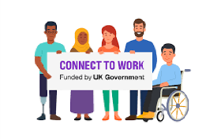 | Employment sub meeting update  James gave an update on the Employment  Group.  - The Employment group has not met for a while as there has been some transition within the Advocacy network. Kerry will be chairing this meeting moving forward.  - A date has been booked for the next meeting which will be Thursday 17th September 2:00-3:30pm.

7. | 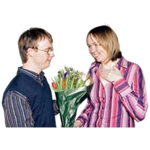 | Update from FAR Group  
8. |  | Update from Peer  Advocate Network  
9. |  | Update from Health  Group  
10. |  | Any other business  We spoke about the awards ceremony that is hosted by People first, it was agreed that it would not be happening this year but would now be moved to the start of next year.  It was agreed by the board that in the December meeting it will be discussed what the workplan will be for next year for the subgroups to avoid any duplication.  3 things to take away from the meeting  - Jon Sorros  The first thing is around John's sorrows and his, it was a great presentation. That's, you know, it's a positive start to the relationship.  - Local Government Reorganisation  There is lots of work happening behind the scenes, but we don't know about it. And so, it's important that we seek assurance that people have learned disabilities are left behind, that we're informed and checked up to date and included. I've already emailed Stephen to ask if we could have somebody to come to the group to help with get us to understand about it.  - Easy read plan for the Partnership board.  The need for an easy read plan for the Lancashire  - Partnership Board  - What is our offer?  - How do people access it?  - Whose role is it?  - What training is needed and so forth.
11. |  | Next meeting.  14th October 2026 at 10:00am-12:30pm
12. | 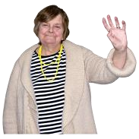 | End of meeting.  Linda and Lindsay thanked everyone for coming and wished everyone a good week.

